AWS VPC PEERING
Student Project Report
Student Name | Shubham Aadinath Warade
Batch | Aws Internship Batch 1
Project Title | AWS VPC Peering
AWS Region | Mumbai (ap-south-1)
Completion Date | 20/10/2026
Prepared in accordance with the EWB Cloud Labs AWS VPC Peering student workbook checklist.

Project Overview
This project establishes private IPv4 connectivity between two Amazon Virtual Private Clouds (VPCs) using VPC Peering. A bastion host in VPC A provides SSH access to private EC2 instances. Route tables direct traffic for the remote VPC CIDR through the peering connection, while security groups control SSH and ICMP traffic.

Objectives
- Create two VPCs with non-overlapping IPv4 CIDR ranges.
- Configure public and private subnets and route tables.
- Establish and validate a VPC peering connection.
- Use a bastion host to access private instances.
- Test forward and reverse ICMP connectivity.
- Demonstrate a controlled ICMP failure and recovery.

AWS Environment and Resource Inventory
Resource | Name / Identifier | Address / CIDR | AWS Resource ID
VPC A | ewb-vpc-a | 10.10.0.0/16 | vpc-00dfb5008df40ac1a
VPC B | ewb-vpc-b | 10.20.0.0/16 | vpc-0371038f236fdac2f
Public subnet A | ewb-a-public | 10.10.1.0/24 | subnet-0e1801db14a1350b6
Private subnet A | ewb-a-private | 10.10.2.0/24 | subnet-0d80738ae3e381998
Private subnet B | ewb-b-private | 10.20.1.0/24 | subnet-0c621bfed31131c7d
Internet Gateway | ewb-igw-a | Attached to VPC A | igw-0536f9ed1b7fdc1d5
VPC Peering | ewb-a-b-peer | Active (last verified) | pcx-077a5f51beee0b60d
Bastion EC2 | ewb-bastion | Private 10.10.1.10; public 3.109.5.222 | i-0d4819ed3a6869ba9
App-A EC2 | ewb-app-a | 10.10.2.10; no public IPv4 | i-07a5b4b676ef90f03
App-B EC2 | ewb-app-b | 10.20.1.10; no public IPv4 | i-0addd4df39d3d92a4

Network Address Plan
VPC | Subnet | CIDR | Purpose
VPC A (10.10.0.0/16) | ewb-a-public | 10.10.1.0/24 | Bastion host
VPC A (10.10.0.0/16) | ewb-a-private | 10.10.2.0/24 | Private App-A instance
VPC B (10.20.0.0/16) | ewb-b-private | 10.20.1.0/24 | Private App-B instance

Route Tables and Associations
Route table | Subnet association | Routes
ewb-rt-a-public | ewb-a-public | VPC A local route; 0.0.0.0/0 → ewb-igw-a; 10.20.0.0/16 → ewb-a-b-peer
ewb-rt-a-private | ewb-a-private | VPC A local route; 10.20.0.0/16 → ewb-a-b-peer
ewb-rt-b-private | ewb-b-private | VPC B local route; 10.10.0.0/16 → ewb-a-b-peer
Traffic from App-A to App-B is routed using the 10.20.0.0/16 route in VPC A. The return traffic uses the
10.10.0.0/16 route in VPC B. Both directions are required for successful two-way communication.

Security Group Rules
Security group | Inbound rule | Source
ewb-sg-bastion | SSH TCP 22 | Current public IP /32 (as configured)
ewb-sg-app-a | SSH TCP 22 | 10.10.1.10/32 (bastion)
ewb-sg-app-a | ICMP Echo Request | 10.20.1.10/32 (App-B)
ewb-sg-app-b | SSH TCP 22 | 10.10.1.10/32 (bastion)
ewb-sg-app-b | ICMP Echo Request | 10.10.2.10/32 (App-A)

Validation and Test Results
The following results are based on the recorded project test notes. Screenshots still need to be captured and added to the report.
Test | Command / action | Recorded result
Baseline before peering | App-A to App-B ping before peering routes/connectivity were configured | Not captured. Do not present as measured evidence.
Forward ping | App-A: ping -c 4 10.20.1.10 | 4 transmitted, 4 received, 0% loss; avg about  0.274 ms
Reverse ping | App-B: ping -c 4 10.10.2.10 | 4 transmitted, 4 received, 0% loss; avg about  0.199 ms
SSH to App-B | SSH from client through bastion; run hostname and hostname -I | Successful; host reported 10.20.1.10
Controlled ICMP failure | Remove App-B ICMP Echo Request inbound rule from 10.10.2.10/32; ping  App-B from App-A | 100% packet loss
Recovery | Restore the same ICMP rule and repeat App-A ping | 4/4 received, 0% loss

Interpretation
The successful forward and reverse pings indicate that the peering routes and ICMP security-group rules allowed traffic in both directions at the time of testing. Removing the destination-side ICMP Echo Request rule caused the controlled failure. Restoring that rule returned the ping test to success.

Architecture Diagram and Screenshot Evidence
Insert the actual architecture diagram and label each screenshot with the host, test, and result. Recommended evidence: VPC details, subnet CIDRs, all three route tables with associations, active peering connection, inbound rules for each security group, forward ping, reverse ping, SSH to App-B, controlled ICMP failure, and recovery.
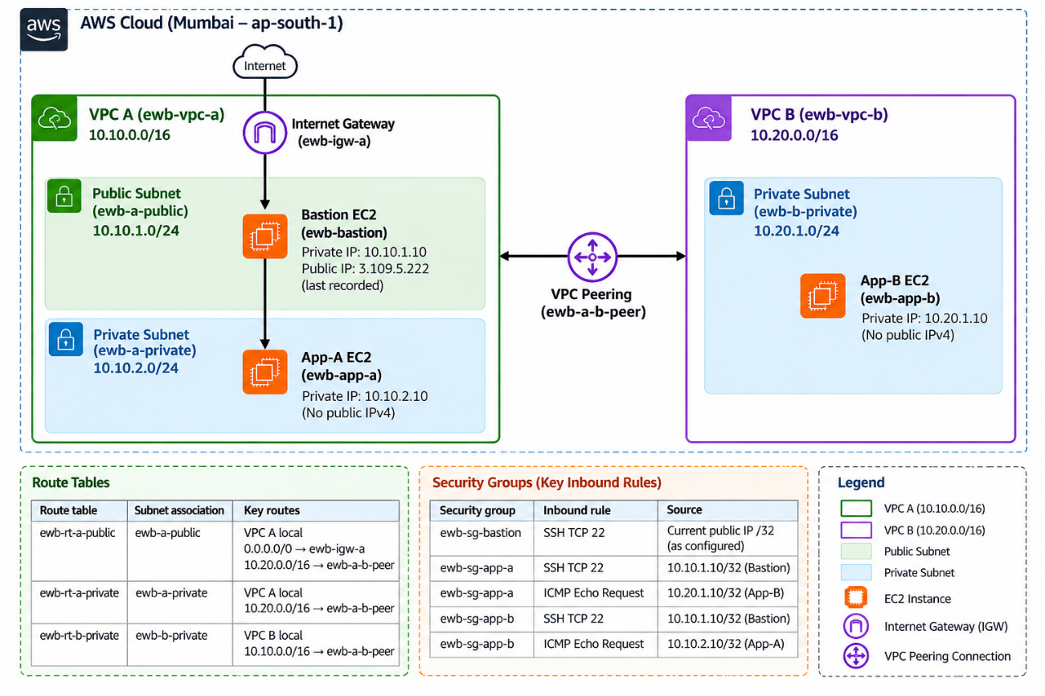

VPC A and VPC B
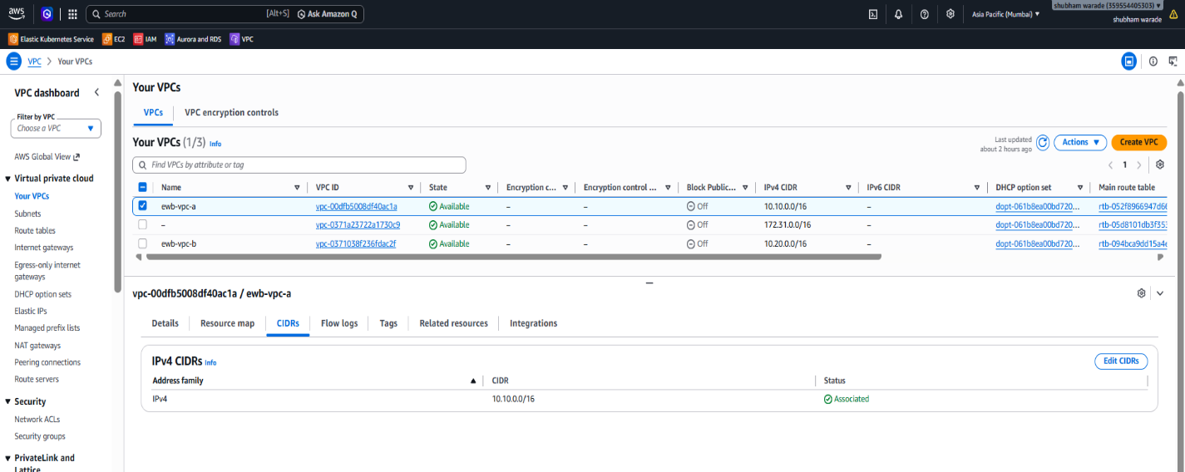

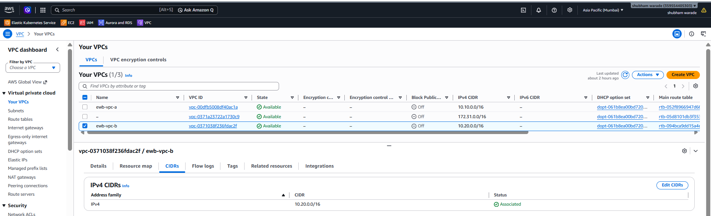
Subnets
